Mid-Term Review
Chapter 2:
Be able to give a description of the following terms and explain why the following people or items are important.
The Astrolabe:

The Caravel:

Christopher Columbus:

Columbian Exchange:

Conquistadors:

Hernan Cortes:

Moctezuma II:

Protestant reformation:

Queen Elizabeth I:

Northwest Passage:

The Middle Passage:

African Diaspora:

Chapter 3:
Be able to give a description of the following terms and explain why the following people or items are important.
The Boston Massacre:

The Boston Tea Party:

Jamestown:

Jonathan Edwards:

Immigrants:

Indentured Servants:

Intolerable Acts:

Pilgrims:

Puritans:

Staple Crops:

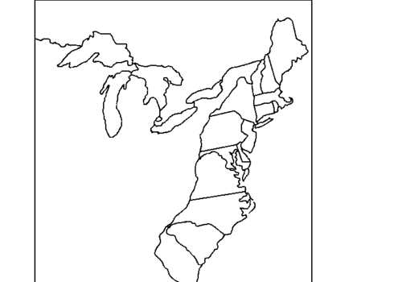
Be able to identify the original 13 colonies on this map:
New Hampshire
Massachusetts
Connecticut
Rhode Island
New York
Pennsylvania
New Jersey
Maryland
Delaware
Virginia
North Carolina
South Carolina
Georgia

Chapter 4:
Be able to give a description of the following terms and explain why the following people or items are important.
The Declaration of Independence:

George Washington:

Liberty:

Mercenary:

Patriot:

Why were these important battles in the American Revolution?

Lexington and Concord:

Trenton:

Saratoga:

Yorktown:

Chapter 5:
Be able to give a description of the following terms and explain why the following people or items are important.
Anti-Federalists:

Articles of Confederation:

Checks and Balances:

Federalism:

Federalists:

Great Compromise:

James Madison:

Ratify:

Tariff:

Three-Fifths Compromise:

Shays’ Rebellion:

Be able to explain what was established because of the Northwest Ordinance shown on this map:
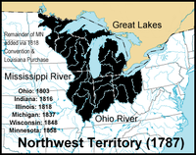

Chapter 6:
Be able to give a description of the following terms and explain why the following people or items are important.
1st Amendment:

2nd Amendment:

3rd Amendment:

4th Amendment:

5th Amendment:

6th Amendment:

7th Amendment:

8th Amendment:

9th Amendment:

10th Amendment:

Executive Branch:

Judicial Branch:

Legislative Branch:

