Name: ____________________________ Date: ______ Hour: ____

Cell City Comparison Project

The cell plays a very important role in the life of all living things. Each living thing, whether it be a person, animal, fish, or bird, has thousands of cells. Within these cells are even tinier parts that help the cell to live. These tiny parts, or organelles, have special jobs to help keep the cell alive.

In this project, you will look over and think about all of the organelles within the cell. More specifically, you will think about the jobs each of these parts has in keeping the cell alive. Then, you will compare these parts to other parts of our life that may have similar jobs.

Your task is going to be to compare the cell to some place within the world. This place can be a city, a baseball park, an amusement park, an arcade game, or something else similar to a cell. You will then make comparisons about the cell and the object you chose to compare it to. You will complete a comparison grid, showing how the jobs/parts are similar and also a drawing to show how these parts are all connected. Lastly, you will make a picture showing the place you chose, all of the cell parts/objects in the place you chose, and label it.

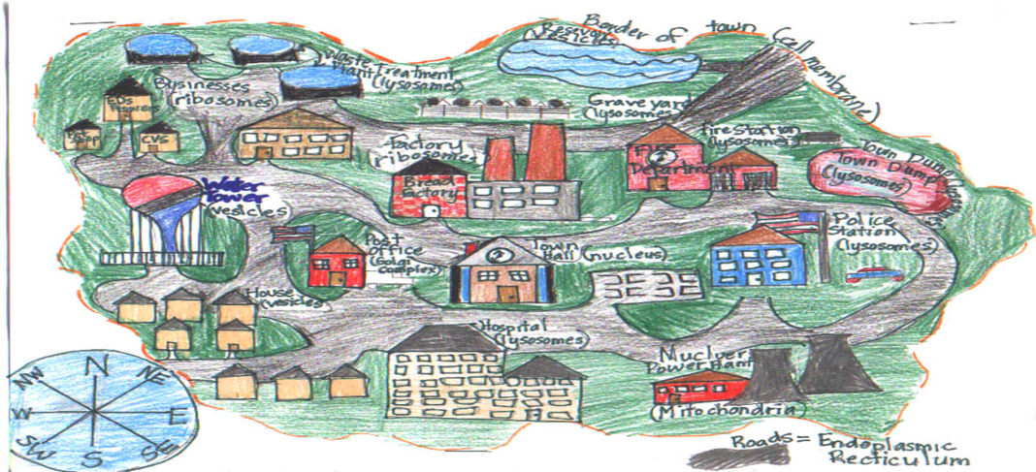

Example: A cell is compared to a city
Cell Part | City Part | What both parts do
Cell Membrane | City boundary line | Outlines the cell/city so you know how big it is
Mitochondria | Power Plant | Helps to bring power to the city/cell so that they can both function
Vacuole | Water Tower/Water Treatment Plant | Stores water for the cell/city so that the cell/people in the city can continue to stay hydrated
Nucleus
Part I: Choose a place to compare your cell parts to in real life.

Place I will be comparing a cell to in real life: _________________________

Part II: Complete the table below showing how the cell part matches to some part in your place. Then describe what job they both have.

You must include the following cell parts and compare them to the object that you chose. Use the sample on the front page to help you, if needed.

Cell Part | Object in that Place | What both parts do
Cell Membrane
Nucleus
Vacuole
Mitochondria
Golgi Apparatus
Cytoplasm
Lysosome
Rough Endoplasmic Reticulum (makes food)
Centriole (optional)

Part III: Drawing of Place and objects that are like a cell. You must include labels as well, like the sample on the front page. Make a small sketch to plan before starting your final copy.

