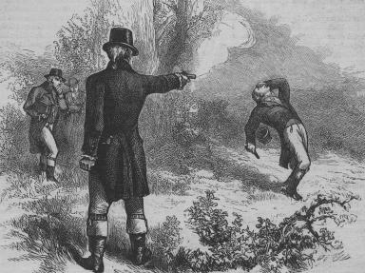
The duel between Alexander Hamilton and Aaron Burr is not only one of the more fascinating parts of early United States history but also one whose impact cannot be overstated. The foundation of their rivalry was set many years before they actually met on a fateful day in July of 1804.

Causes of the Rivalry Between Alexander Hamilton and Aaron Burr
The rivalry between Alexander Hamilton and Aaron Burr had its roots in a 1791 Senate race.
Aaron Burr defeated Philip Schuyler who was Hamilton's father-in-law. Schuyler as a Federalist would have supported George Washington's and Hamilton's policies while Burr as a Democratic-Republican opposed those policies.
The relationship only became more fractured during the election of 1800. The electoral college was at an impasse as to the selection of the president between Thomas Jefferson who was supposed to be running for president and Aaron Burr who was to be the Vice President. However, once the votes were counted, both Jefferson and Burr were tied. While Hamilton didn't support either candidate, he couldn't stand Burr more than Jefferson.
Through his maneuverings in the House of Representatives, Jefferson became president and Burr was named his Vice President.
In 1804, Alexander Hamilton again entered the fray in a campaign against Aaron Burr. Burr was running for New York Governor and Hamilton campaigned against him thereby helping Morgan Lewis to win. This only created further animosity between the two men.
The situation worsened when Hamilton criticized Burr at a dinner party.
Angry letters were exchanged between the two men with Burr asking for Hamilton to apologize. When Hamilton would not do so, Burr challenged him to a duel.

Duel Between Alexander Hamilton and Aaron Burr
On July 11, 1804, in the early morning hours, Hamilton met Burr at the agreed upon site at the Heights of Weehawken in New Jersey. Aaron Burr and his second, William P. Van Ness, cleared the dueling grounds of trash and Alexander Hamilton and his second, Nathaniel Pendelton, arrived shortly before 7 AM. It is believed that Hamilton fired first and probably honored his pre-duel pledge to throw away his shot.
However, his unorthodox manner of firing up instead of into the ground gave Burr the justification to take aim and shoot Hamilton. The bullet from Burr struck Hamilton in the abdomen and probably did significant damage to his internal organs. He died from his wounds a day later.

Aftermath of Alexander Hamilton's Death
The duel ended the life of one of the greatest minds of Federalist Party and the early U.S. Government. Alexander Hamilton as Secretary of the Treasury had a significant impact on the commercial underpinning of the new federal government. The duel also made Burr a pariah in the political landscape of the U.S. Although his duel was considered to be within the bounds of the moral ethics of the time, his political aspirations were ruined.

